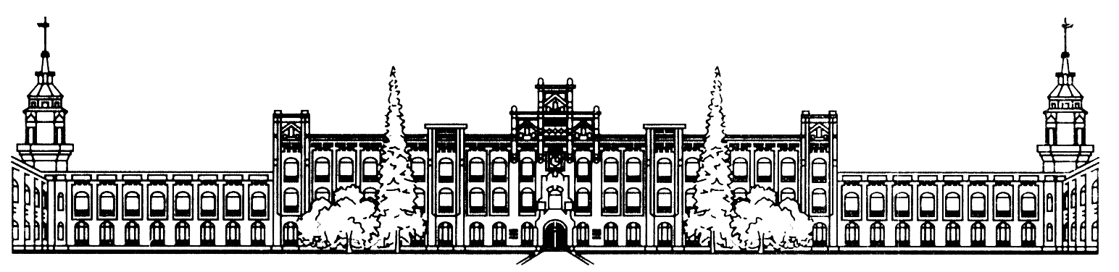МІНІСТЕРСТВО ОСВІТИ І НАУКИ УКРАЇНИ

НАЦІОНАЛЬНИЙ ТЕХНІЧНИЙ УНИВЕРСИТЕТ УКРАЇНИ

«КИЇВСЬКИЙ ПОЛІТЕХНІЧНИЙ ІНСТИТУТ ім. Ігоря Сікорського»

КАФЕДРА

АВТОМАТИЗОВАНИХ СИСТЕМ ОБРОБКИ ІНФОРМАЦІЇ ТА УПРАВЛІННЯ

Звіт

З ЛАБОРАТОРНОЇ РОБОТИ

***«Використання програмних пакетів для розробки CSS-оформлення»***

*«Основи клієнтської розробки»*

|  |  |  |
| --- | --- | --- |
| Перевірив: ас. Ковтунець О.В. |  | Виконав: студент 2 курсу ФІОТ  групи ІП-72  Нестеренко Єгор |
|  |  | Залікова книжка №ІП 7219 |
|  |  |  |

Київ – 2018

**Завдання**

Створіть сайт з обраної самостійно тематики.

Хід виконання:

1. Створіть п’ять HTML-документів, пов’яжіть їх між собою посиланнями.
2. Використайте теги DIV, SPAN, P, H1, H2, H3, A, UL, OL, LI, TABLE, TR, TD для виділення окремих структурних елементів HTML-сторінки.
3. Використайте теги IMG, A, MAP для додавання на HTML-сторінки зображень, посилань та карт посилань із них.
4. Перегляньте сайт через локальну файлову систему. Викладіть ваш сайт на Github.
5. Порівняйте способи доступу до HTML-сторінок через локальну файлову систему і через інтернет. При потребі підкоригуйте роботу посилань.

Скріншот результатів

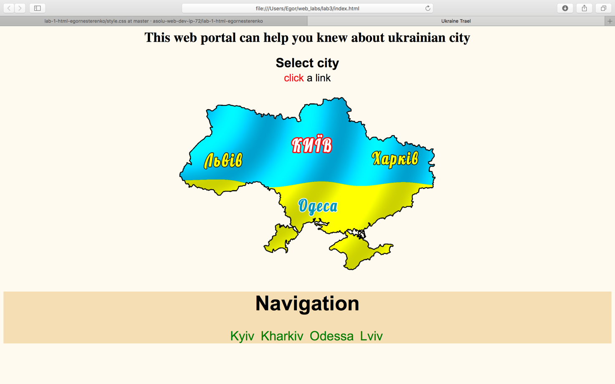

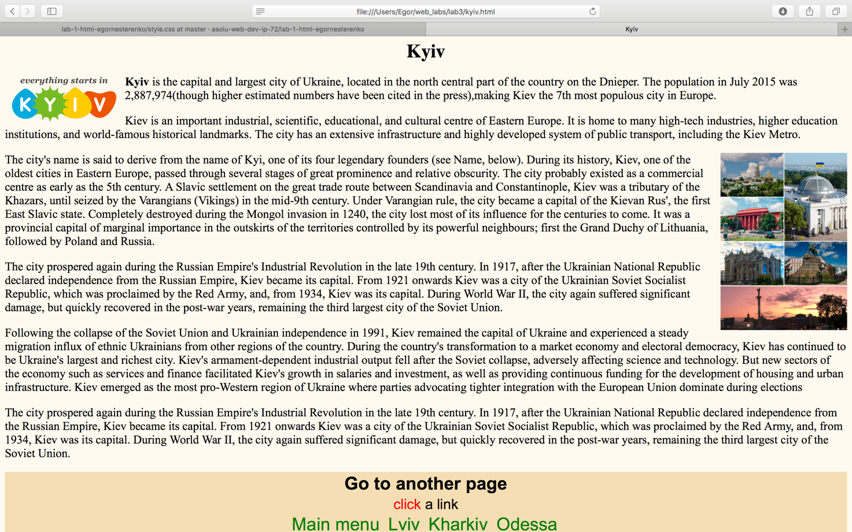

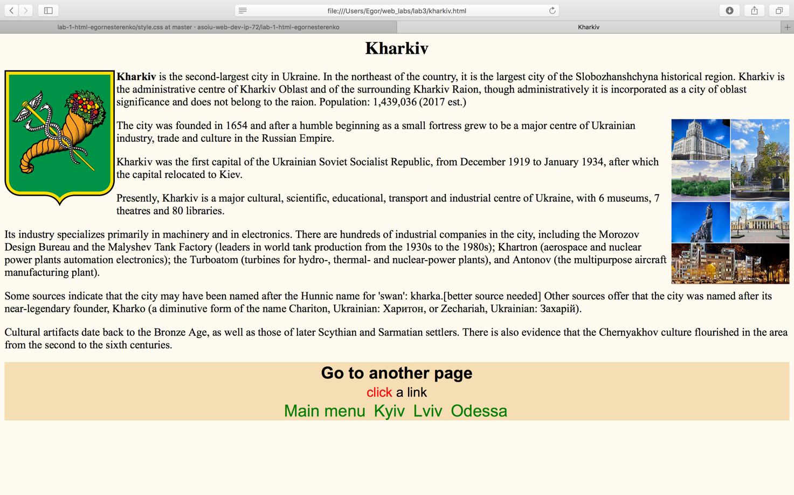

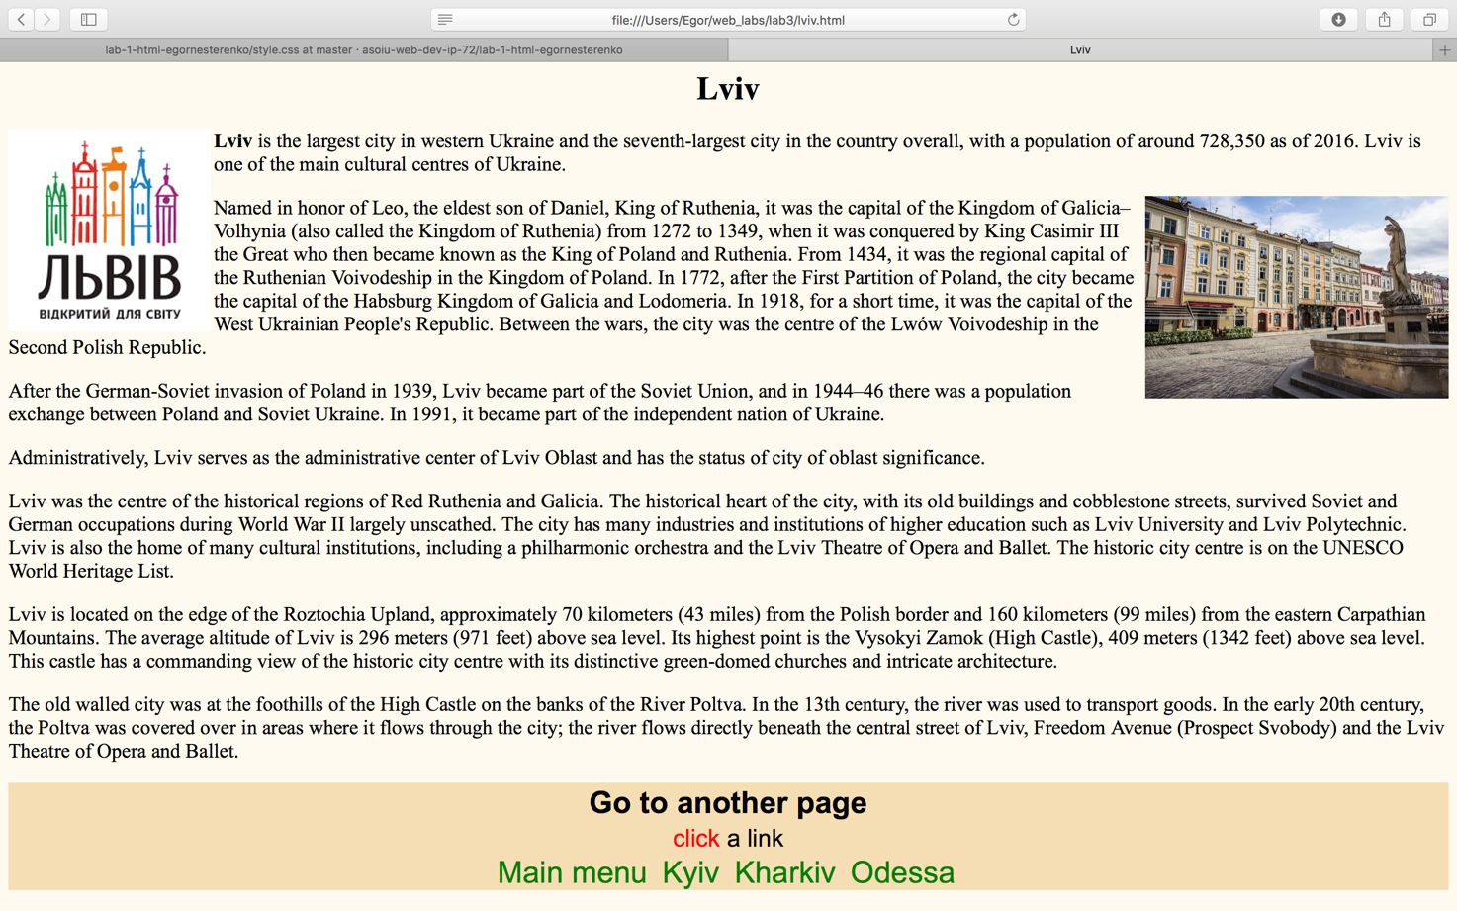

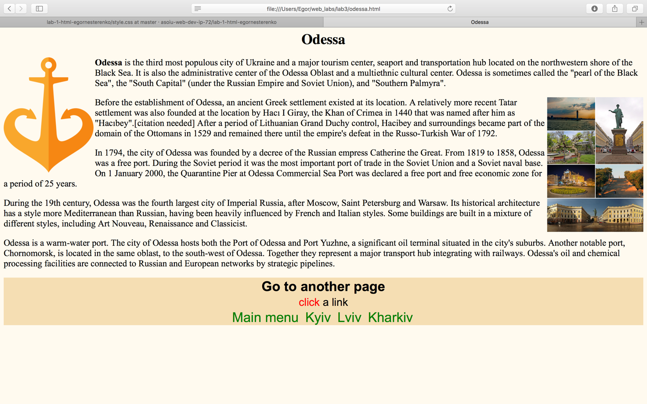

Код

index.html:

<html>

<head>

<meta charset="utf-8">

<title>Ukraine Trael</title>

<link type="text/css" rel="stylesheet" href="style.css">

</head>

<body>

<h1 align="center"><b> This web portal can help you knew about ukrainian city</b></h1>

<div align="center">

<table>

<tr colspan="2">

<th> <b> <span style="font-size: 30px;">Select city</b> </th>

</tr>

<tr>

<td> <div align="center">

<span style="color: red;">click </span>

a link </div>

</td>

</tr>

</table>

<br>

<img src="img/FlagMap_of_Ukraine.png" width="600px" align="center", usemap="#karta">

</div>

<map name="karta">

<area shape="rect" coords="0,100,170,200" href="lviv.html" alt="Lviv">

<area shape="rect" coords="250,70,370,140" href="kyiv.html" alt="Kyiv">

<area shape="rect" coords="430,120,570,170" href="kharkiv.html" alt="Kharkiv">

<area shape="rect" coords="270,230,370,270" href="odessa.html" alt="Odesa">

</map>

<br>

<div align="center" style="background-color: #F5DEB3">

<h1>Navigation</h1>

<ul class="menu">

<li><a href="kyiv.html">Kyiv</a></li>

<li><a href="kharkiv.html">Kharkiv</a></li>

<li><a href="odessa.html">Odessa</a></li>

<li><a href="lviv.html">Lviv</a></li>

</ul>

</div>

<br>

</body>

</html> </body>

kyiv.html:

<html>

<head>

<meta charset="utf-8">

<title>Kyiv</title>

<link type="text/css" rel="stylesheet" href="style.css">

</head>

<body>

<h1 align="center"><b> Kyiv</b></h1>

<img src="img/kyiv.png" width="200" align="left">

<p><b>Kyiv</b> is the capital and largest city of Ukraine, located in the north central part of the country on the Dnieper. The population in July 2015 was 2,887,974(though higher estimated numbers have been cited in the press),making Kiev the 7th most populous city in Europe.</p>

<p>Kiev is an important industrial, scientific, educational, and cultural centre of Eastern Europe. It is home to many high-tech industries, higher education institutions, and world-famous historical landmarks. The city has an extensive infrastructure and highly developed system of public transport, including the Kiev Metro.</p>

<img src="img/kyiv2.png" height="300" align="right">

<p>The city's name is said to derive from the name of Kyi, one of its four legendary founders (see Name, below). During its history, Kiev, one of the oldest cities in Eastern Europe, passed through several stages of great prominence and relative obscurity. The city probably existed as a commercial centre as early as the 5th century. A Slavic settlement on the great trade route between Scandinavia and Constantinople, Kiev was a tributary of the Khazars, until seized by the Varangians (Vikings) in the mid-9th century. Under Varangian rule, the city became a capital of the Kievan Rus', the first East Slavic state. Completely destroyed during the Mongol invasion in 1240, the city lost most of its influence for the centuries to come. It was a provincial capital of marginal importance in the outskirts of the territories controlled by its powerful neighbours; first the Grand Duchy of Lithuania, followed by Poland and Russia.</p>

<p>The city prospered again during the Russian Empire's Industrial Revolution in the late 19th century. In 1917, after the Ukrainian National Republic declared independence from the Russian Empire, Kiev became its capital. From 1921 onwards Kiev was a city of the Ukrainian Soviet Socialist Republic, which was proclaimed by the Red Army, and, from 1934, Kiev was its capital. During World War II, the city again suffered significant damage, but quickly recovered in the post-war years, remaining the third largest city of the Soviet Union.</p>

<p>Following the collapse of the Soviet Union and Ukrainian independence in 1991, Kiev remained the capital of Ukraine and experienced a steady migration influx of ethnic Ukrainians from other regions of the country. During the country's transformation to a market economy and electoral democracy, Kiev has continued to be Ukraine's largest and richest city. Kiev's armament-dependent industrial output fell after the Soviet collapse, adversely affecting science and technology. But new sectors of the economy such as services and finance facilitated Kiev's growth in salaries and investment, as well as providing continuous funding for the development of housing and urban infrastructure. Kiev emerged as the most pro-Western region of Ukraine where parties advocating tighter integration with the European Union dominate during elections</p>

<p>The city prospered again during the Russian Empire's Industrial Revolution in the late 19th century. In 1917, after the Ukrainian National Republic declared independence from the Russian Empire, Kiev became its capital. From 1921 onwards Kiev was a city of the Ukrainian Soviet Socialist Republic, which was proclaimed by the Red Army, and, from 1934, Kiev was its capital. During World War II, the city again suffered significant damage, but quickly recovered in the post-war years, remaining the third largest city of the Soviet Union.</p>

<div align="center" style="background-color: #F5DEB3">

<table>

<tr colspan="2">

<th> <b> <span style="font-size: 30px;">Go to another page</b> </th>

</tr>

<tr>

<td> <div align="center">

<span style="color: red;">click </span>

a link </div>

</td>

</tr>

</table>

<ul class="menu">

<li><a href="index.html">Main menu</a></li>

<li><a href="lviv.html">Lviv</a></li>

<li><a href="kharkiv.html">Kharkiv</a></li>

<li><a href="odessa.html">Odessa</a></li>

</ul>

</div>

<br>

</body>

</html>

kharkiv.html:

<html>

<head>

<meta charset="utf-8">

<title>Kharkiv</title>

<link type="text/css" rel="stylesheet" href="style.css">

</head>

<body>

<h1 align="center"><b> Kharkiv</b></h1>

<img src="img/kh.png" width="200px" align="left">

<p><b> Kharkiv </b> is the second-largest city in Ukraine. In the northeast of the country, it is the largest city of the Slobozhanshchyna historical region. Kharkiv is the administrative centre of Kharkiv Oblast and of the surrounding Kharkiv Raion, though administratively it is incorporated as a city of oblast significance and does not belong to the raion. Population: 1,439,036 (2017 est.)</p>

<img src="img/kh2.png" height="300px" align="right">

<p>The city was founded in 1654 and after a humble beginning as a small fortress grew to be a major centre of Ukrainian industry, trade and culture in the Russian Empire.</p>

<p>Kharkiv was the first capital of the Ukrainian Soviet Socialist Republic, from December 1919 to January 1934, after which the capital relocated to Kiev.</p>

<p>Presently, Kharkiv is a major cultural, scientific, educational, transport and industrial centre of Ukraine, with 6 museums, 7 theatres and 80 libraries.</p>

<p>Its industry specializes primarily in machinery and in electronics. There are hundreds of industrial companies in the city, including the Morozov Design Bureau and the Malyshev Tank Factory (leaders in world tank production from the 1930s to the 1980s); Khartron (aerospace and nuclear power plants automation electronics); the Turboatom (turbines for hydro-, thermal- and nuclear-power plants), and Antonov (the multipurpose aircraft manufacturing plant).</p>

<p>Some sources indicate that the city may have been named after the Hunnic name for 'swan': kharka.[better source needed] Other sources offer that the city was named after its near-legendary founder, Kharko (a diminutive form of the name Chariton, Ukrainian: Харитон, or Zechariah, Ukrainian: Захарій).</p>

<p>Cultural artifacts date back to the Bronze Age, as well as those of later Scythian and Sarmatian settlers. There is also evidence that the Chernyakhov culture flourished in the area from the second to the sixth centuries.</p>

<div align="center" style="background-color: #F5DEB3">

<table>

<tr colspan="2">

<th> <b> <span style="font-size: 30px;">Go to another page</b> </th>

</tr>

<tr>

<td> <div align="center">

<span style="color: red;">click </span>

a link </div>

</td>

</tr>

</table>

<ul class="menu">

<li><a href="index.html">Main menu</a></li>

<li><a href="kyiv.html">Kyiv</a></li>

<li><a href="lviv.html">Lviv</a></li>

<li><a href="odessa.html">Odessa</a></li>

</ul>

</div>

<br>

</body>

</html>

lviv.html:

<html>

<head>

<meta charset="utf-8">

<title>Lviv</title>

<link type="text/css" rel="stylesheet" href="style.css">

</head>

<body>

<h1 align="center"><b> Lviv</b></h1>

<img src="img/lviv.png" width="200px" align="left">

<p> <b>Lviv</b> is the largest city in western Ukraine and the seventh-largest city in the country overall, with a population of around 728,350 as of 2016. Lviv is one of the main cultural centres of Ukraine. </p>

<img src="img/lviv2.jpg" width="300px" align="right">

<p>Named in honor of Leo, the eldest son of Daniel, King of Ruthenia, it was the capital of the Kingdom of Galicia–Volhynia (also called the Kingdom of Ruthenia) from 1272 to 1349, when it was conquered by King Casimir III the Great who then became known as the King of Poland and Ruthenia. From 1434, it was the regional capital of the Ruthenian Voivodeship in the Kingdom of Poland. In 1772, after the First Partition of Poland, the city became the capital of the Habsburg Kingdom of Galicia and Lodomeria. In 1918, for a short time, it was the capital of the West Ukrainian People's Republic. Between the wars, the city was the centre of the Lwów Voivodeship in the Second Polish Republic.</p>

<p>After the German-Soviet invasion of Poland in 1939, Lviv became part of the Soviet Union, and in 1944–46 there was a population exchange between Poland and Soviet Ukraine. In 1991, it became part of the independent nation of Ukraine.</p>

<p>Administratively, Lviv serves as the administrative center of Lviv Oblast and has the status of city of oblast significance.</p>

<p>Lviv was the centre of the historical regions of Red Ruthenia and Galicia. The historical heart of the city, with its old buildings and cobblestone streets, survived Soviet and German occupations during World War II largely unscathed. The city has many industries and institutions of higher education such as Lviv University and Lviv Polytechnic. Lviv is also the home of many cultural institutions, including a philharmonic orchestra and the Lviv Theatre of Opera and Ballet. The historic city centre is on the UNESCO World Heritage List.</p>

<p>Lviv is located on the edge of the Roztochia Upland, approximately 70 kilometers (43 miles) from the Polish border and 160 kilometers (99 miles) from the eastern Carpathian Mountains. The average altitude of Lviv is 296 meters (971 feet) above sea level. Its highest point is the Vysokyi Zamok (High Castle), 409 meters (1342 feet) above sea level. This castle has a commanding view of the historic city centre with its distinctive green-domed churches and intricate architecture.</p>

<p>The old walled city was at the foothills of the High Castle on the banks of the River Poltva. In the 13th century, the river was used to transport goods. In the early 20th century, the Poltva was covered over in areas where it flows through the city; the river flows directly beneath the central street of Lviv, Freedom Avenue (Prospect Svobody) and the Lviv Theatre of Opera and Ballet.</p>

<div align="center" style="background-color: #F5DEB3">

<table>

<tr colspan="2">

<th> <b> <span style="font-size: 30px;">Go to another page</b> </th>

</tr>

<tr>

<td> <div align="center">

<span style="color: red;">click </span>

a link </div>

</td>

</tr>

</table>

<ul class="menu">

<li><a href="index.html">Main menu</a></li>

<li><a href="kyiv.html">Kyiv</a></li>

<li><a href="kharkiv.html">Kharkiv</a></li>

<li><a href="odessa.html">Odessa</a></li>

</ul>

</div>

<br>

</body>

</html>

odessa.html:

<html>

<head>

<meta charset="utf-8">

<title>Odessa</title>

<link type="text/css" rel="stylesheet" href="style.css">

</head>

<body>

<h1 align="center"><b> Odessa</b></h1>

<img src="img/odessa.png" width="200px" align="left">

<p><b> Odessa </b>is the third most populous city of Ukraine and a major tourism center, seaport and transportation hub located on the northwestern shore of the Black Sea. It is also the administrative center of the Odessa Oblast and a multiethnic cultural center. Odessa is sometimes called the "pearl of the Black Sea", the "South Capital" (under the Russian Empire and Soviet Union), and "Southern Palmyra".</p>

<img src="img/odessa2.png" height="300px" align="right">

<p>Before the establishment of Odessa, an ancient Greek settlement existed at its location. A relatively more recent Tatar settlement was also founded at the location by Hacı I Giray, the Khan of Crimea in 1440 that was named after him as "Hacıbey".[citation needed] After a period of Lithuanian Grand Duchy control, Hacibey and surroundings became part of the domain of the Ottomans in 1529 and remained there until the empire's defeat in the Russo-Turkish War of 1792.</p>

<p>In 1794, the city of Odessa was founded by a decree of the Russian empress Catherine the Great. From 1819 to 1858, Odessa was a free port. During the Soviet period it was the most important port of trade in the Soviet Union and a Soviet naval base. On 1 January 2000, the Quarantine Pier at Odessa Commercial Sea Port was declared a free port and free economic zone for a period of 25 years.</p>

<p>During the 19th century, Odessa was the fourth largest city of Imperial Russia, after Moscow, Saint Petersburg and Warsaw. Its historical architecture has a style more Mediterranean than Russian, having been heavily influenced by French and Italian styles. Some buildings are built in a mixture of different styles, including Art Nouveau, Renaissance and Classicist.</p>

<p>Odessa is a warm-water port. The city of Odessa hosts both the Port of Odessa and Port Yuzhne, a significant oil terminal situated in the city's suburbs. Another notable port, Chornomorsk, is located in the same oblast, to the south-west of Odessa. Together they represent a major transport hub integrating with railways. Odessa's oil and chemical processing facilities are connected to Russian and European networks by strategic pipelines.</p>

<div align="center" style="background-color: #F5DEB3">

<table>

<tr colspan="2">

<th> <b> <span style="font-size: 30px;">Go to another page</b> </th>

</tr>

<tr>

<td> <div align="center">

<span style="color: red;">click </span>

a link </div>

</td>

</tr>

</table>

<ul class="menu">

<li><a href="index.html">Main menu</a></li>

<li><a href="kyiv.html">Kyiv</a></li>

<li><a href="lviv.html">Lviv</a></li>

<li><a href="kharkiv.html">Kharkiv</a></li>

</ul>

</div>

<br>

</body>

</html>

style.css:

body {

background-color: #FFFAF0;

}

a {

text-decoration: none;

color: green;

}

a:hover{

color:red;

}

ul.menu{

margin: 0;

padding: 0;

}

ul.menu li{

display: inline;

margin-right: 4px;

padding: 2px;

font-size: 30px;

}

div {

font-size: 24px;

font-family: Arial;

}

p {

font-size: 20px;

font-family: Times New Roman;

}